I received Ninaran’s report on the ratcatchers. Next time you see them, put an end to their meddling. If you cannot do it soon, I’ve asked her to befriend them. That way we may learn their plans and stop them before they interfere.
Mix the blood of ten people with the elixir my messenger brings. Then trace the following pattern on the ground of the temple site and pour the liquid into the lines:
With the thinning of the veil here at the keep, this circle will create a sympathetic connection to the Shadowfell.
My work here is very near completion. It will not be long now. If you come to the keep at midnight, the pass phrase for the second level is “from the ground, some magic was found”.
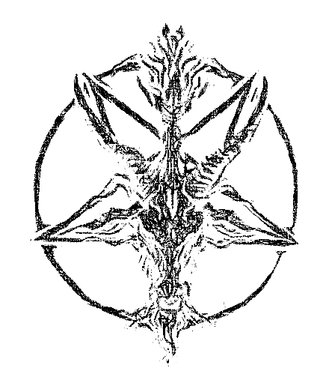
- Kalarel

